D – Intento de Adquisición de Combustible con el Monedero Electrónico (Después del bloqueo)
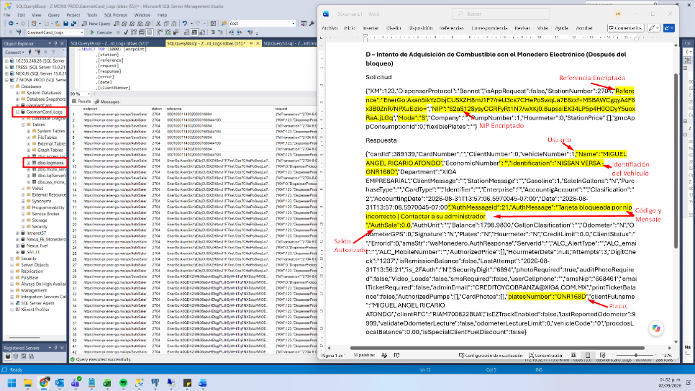
Solicitud
{"KM":123,"DispenserProtocol":"Bennet","isAppRequest":false,"StationNumber":2704,"Reference":"EnerGo:Axan5ikYzDbjCUSXZH8mJ1F7/reU3cs7CHePoSwqLa7E8zxf+MSBAWCgqyA4F8x3B0ZnR/NPXuEizio=","NIP":"$2a$12$ysyCGRFyRt1N7/wXKj0.8upsalEX34LP5p4H0ODyY5uoxRaA.jLGq","Mode":"S","Company":"","PumpNumber":1,"Hourmeter":0,"StationPrice":[],"gmcAppConsumptionId":0,"flexiblePlates":""}
Respuesta
{"cardId":389139,"CardNumber":"","ClientNumber":0,"vehicleNumber":1,"Name":"MIGUEL ANGEL RICARIO ATONDO","EconomicNumber":"","Identification":"NISSAN VERSA -GNR168D","Department":"XIGA EMPRESARIAL","ClientMessage":"","StationMessage":"","Gasoline":1,"SaleInGallons":"N","PurchaseType":"","CardType":"","Identifier":"","Enterprise":"","AccountigAccount":"","Clasification":"2","AccountingDate":"2026-08-31T13:57:06.5970045-07:00","Date":"2026-08-31T13:57:06.5970045-07:00","AuthMessageId":21,"AuthMessage":"Tarjeta bloqueada por nip incorrecto | Contactar a su administrador ","AuthSale":0.0,"AuthUnit":"","Balance":1798.9800,"GallonClasification":"","Odometer":"N","OdometerGPS":0,"Signature":"N","Plates":"N","Hourmeter":"N","CreditLimit":0.0,"ClientStatus":"","ErrorId":0,"smsStr":"wsMonedero.AuthResponse","ServerId":"","ALC_AlertType":"","ALC_email":"","ALC_MobileNumber":"","AuthorizedPrice":[],"HourmeterData":null,"Attempts":3,"DigitCheck":"1237","isRemissionBalance":false,"LastAttempt":"2026-08-31T13:56:21","is_2FAuth":"N","SecurityDigit":"6894","photoRequired":true,"auditPhotoRequired":false,"Video_Loads":false,"smsRequired":false,"userCellphone":"","smsNip":"668461","emailTicketRequired":false,"adminEmail":"CREDITOYCOBRANZA@XIGA.COM.MX","printTicketBalance":false,"AuthorizedPumps":[],"CardPhotos":[],"platesNumber":"GNR168D","clientFullname":"MIGUEL ANGEL RICARIO ATONDO","clientRFC":"RIAM700822BUA","isEZTrackEnabled":false,"lastReportedOdometer":9999,"validateOdometerLecture":false,"odometerLectureLimit":0,"vehicleCode":"0","proodosLocalBalance":0.00,"isSpecialClientFuelDiscount":false}

